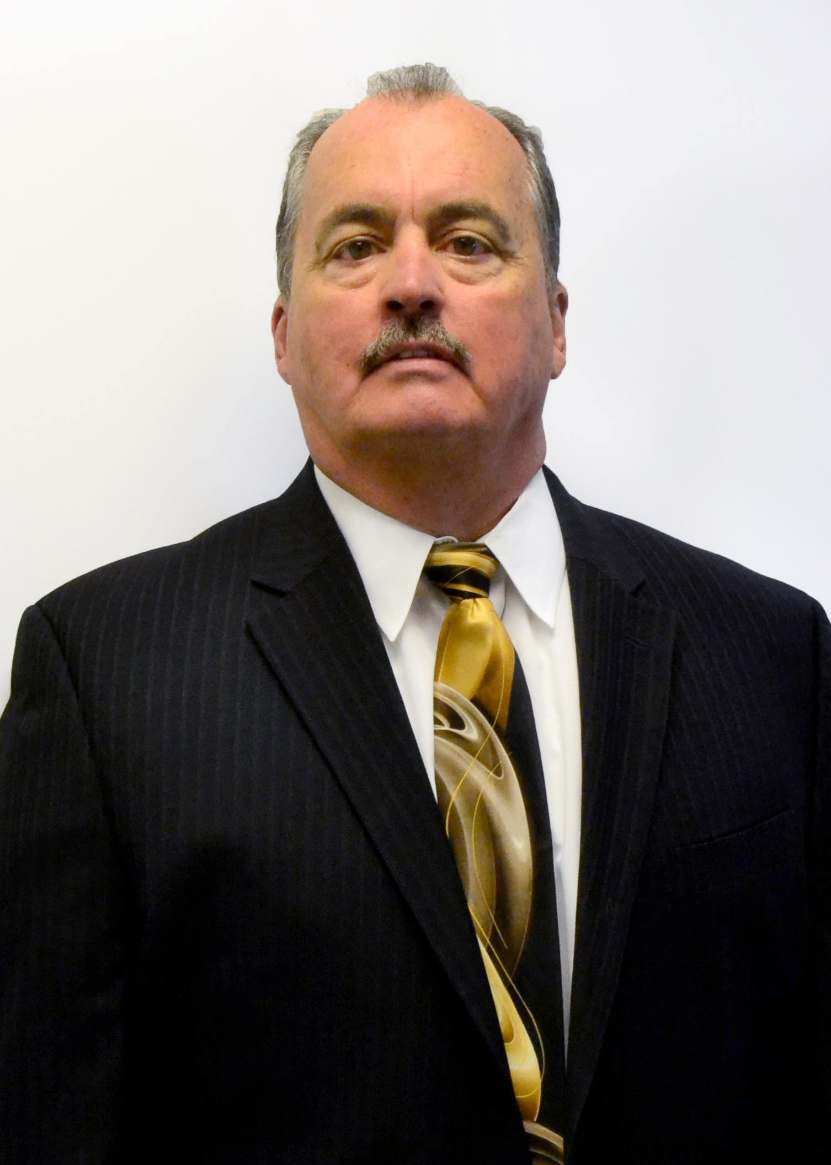

**DLA Troop Support**

**2018 Hall of Fame Inductee**

**KEITH R. FORD**

**Keith R. Ford** is being inducted into the Defense Logistics Agency Troop Support Hall of Fame, Class of 2018 for his outstanding mission support from 1981 through 2016. Mr. Ford began his federal career in 1981 as a GS-5 contract specialist and worked his way up the ranks before retiring as the deputy director of the Clothing and Textiles supply chain where he led a staff of 338 professionals through unprecedented change in uniform requirements.

Mr. Ford served in several capacities throughout his career at DLA Troop Support and its legacy organizations, providing him expertise in contracting, logistics and finance. He was known as the “Father of Prime Vendor” in Subsistence, overseeing the roll-out of a program that is still in existence 20 years later. Mr. Ford’s leadership style was one of trust in his people to do the right thing and to keep him advised of the decisions made. Keith always supported his team and empowered them to run their own programs and be accountable.

While serving as comptroller, Mr. Ford supported DLA Troop Support's wartime requirements during Operation Enduring Freedom and Operation Iraqi Freedom, and oversaw the Enterprise Business Systems roll-out, the organization’s financial backbone. Mr. Ford was the personification of a role model, guiding associates with his commitment to excellence in every task he endeavored.

Mr. Ford’s consistent dedication, commitment, loyalty and vision along with a willingness to dig beneath the surface for solutions indisputably characterized him as a superior leader and individual. For his superior professional credentials, outstanding performance and commitment to warfighter support, Mr. Ford has left a lasting impression on not just DLA Troop Support, but DLA and the Department of Defense.